Experiment-2
Characteristics Study of Side Band Power and Frequencies
In AM Using Matlab

Program (Matlab Code):
clc;
clear;
close all;

% ==========================================
% AM MODULATION AND DEMODULATION
% ==========================================

% -------------------------------
% AM Parameters
% -------------------------------
Am = 1; % Message amplitude
fm = 500; % Message frequency (Hz)

Ac = 5; % Carrier amplitude
fc = 5000; % Carrier frequency (Hz)

fs = 20 * fc; % Sampling frequency
t = 0:1/fs:4/fm; % Time vector

% -------------------------------
% Message Signal
% -------------------------------
m = Am * sin(2*pi*fm*t);

% -------------------------------
% Carrier Signal
% -------------------------------
c = Ac * sin(2*pi*fc*t);

% -------------------------------
% Modulation Index
% -------------------------------
mu = Am / Ac;

% -------------------------------
% AM Modulated Signal
% -------------------------------
am = Ac * (1 + mu*sin(2*pi*fm*t)) ....* sin(2*pi*fc*t);

% -------------------------------
% AM Demodulation
% Envelope Detection
% -------------------------------
envelope = abs(am);

% Moving-average filter
window = round(fs/(10*fm));

dem = zeros(size(envelope));

for k = window:length(envelope) dem(k) = mean(envelope(k-window+1:k));
end

% Remove DC component
dem = dem - mean(dem);

% -------------------------------
% FFT Analysis
% -------------------------------
N = length(am);

AM_FFT = abs(fftshift(fft(am))) / N;

% Correct frequency axis
f = (-N/2:N/2-1) * (fs/N);

% -------------------------------
% Sideband Frequencies
% -------------------------------
USB = fc + fm;
LSB = fc - fm;

% -------------------------------
% Power Calculation
% -------------------------------
Pc = Ac^2 / 2; % Carrier power

Psb = (mu^2 * Pc) / 4; % Power in each sideband

% ==========================================
% PLOTTING
% ==========================================

figure('Name','AM Modulation Experiment', ... 'NumberTitle','off', ...
'Position',[100 50 1000 850]);

% -------------------------------
% 1. Message Signal
% -------------------------------
subplot(3,2,1);

plot(t,m,'LineWidth',1.2);

title('Message Signal');
xlabel('Time (s)');
ylabel('Amplitude');

grid on;

% -------------------------------
% 2. Carrier Signal
% -------------------------------
subplot(3,2,2);

plot(t,c,'LineWidth',1.2);

title('Carrier Signal');
xlabel('Time (s)');
ylabel('Amplitude');

grid on;

% -------------------------------
% 3. AM Modulated Signal
% -------------------------------
subplot(3,2,3);

plot(t,am,'LineWidth',1.2);

title('AM Modulated Signal');
xlabel('Time (s)');
ylabel('Amplitude');

grid on;

% -------------------------------
% 4. Demodulated Signal
% -------------------------------
subplot(3,2,4);

plot(t,dem,'LineWidth',1.2);

title('Demodulated Signal');
xlabel('Time (s)');
ylabel('Amplitude');

grid on;

% -------------------------------
% 5. AM Spectrum
% -------------------------------
subplot(3,2,5);

plot(f,AM_FFT,'LineWidth',1.2);

xlim([fc-3*fm fc+3*fm]);

title('AM Spectrum');
xlabel('Frequency (Hz)');
ylabel('Magnitude');

grid on;

% -------------------------------
% 6. Power Distribution
% -------------------------------
subplot(3,2,6);

bar([Pc Psb Psb]);

set(gca,'XTick',1:3);
set(gca,'XTickLabel',{'Carrier','USB','LSB'});

title('Power Distribution');
xlabel('Component');
ylabel('Power (W)');

grid on;

% ==========================================
% DISPLAY RESULTS
% ==========================================

fprintf('\n');
fprintf('=========================================\n');
fprintf(' AM MODULATION RESULTS\n');
fprintf('=========================================\n');

fprintf('Modulation Index (mu) = %.2f\n',mu);

fprintf('Carrier Frequency = %.0f Hz\n',fc);

fprintf('Message Frequency = %.0f Hz\n',fm);

fprintf('USB Frequency = %.0f Hz\n',USB);

fprintf('LSB Frequency = %.0f Hz\n',LSB);

fprintf('Carrier Power = %.2f W\n',Pc);

fprintf('Each Sideband Power = %.3f W\n',Psb);

fprintf('=========================================\n');

Output Waveform :

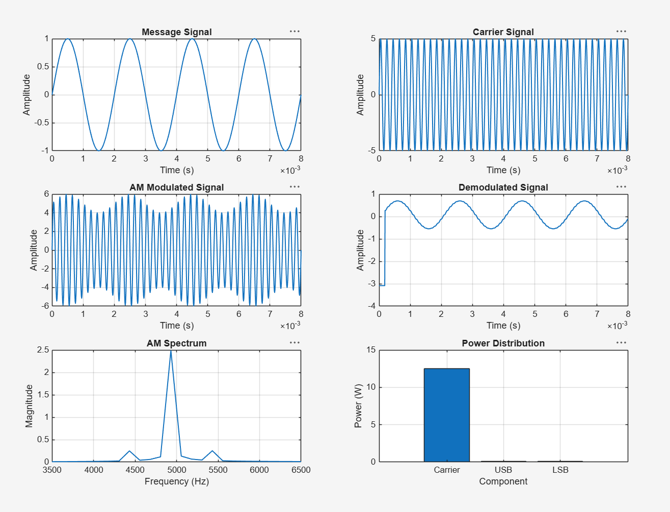

Command Window :
